Spring Interview Questions :-

What is Oauth2.0 Authorization :-

The OAuth 2.0 specification defines a delegation protocol that is useful for conveying authorization decisions across a network of web-enabled applications and APIs. OAuth is used in a wide variety of applications, including providing mechanisms for user authentication.
It is an authorization framework that provides some standardized rules for authorization. It was first created in 2006 and the first version was OAuth.

OAuth Roles
OAuth specifies four roles:
- Resource owner (the User) – an entity capable of granting access to a protected resource (for example end-user). The person or any entity that can provide access to the protected resources.
- Resource server (the API server) – the server hosting the protected resources, capable of accepting responding to protected resource requests using access tokens. It can be your application, which provides an access token to the end-user or client so that they can access the protected resource.
Note: Here protected resources refer to the API, web pages, etc which you developed or created, more technically we can say protected resources is HTTP Endpoints, the resources which are static.
- Client – an application making protected resource requests on behalf of the resource owner and with its authorization.
It is the one who requested the Resource owner or Authorization Server to provide access to the protected resources such as Apis or HTTP Endpoints.
Here the client can be UI/UX also or when you search anything on the internet, then the URL which you enter on the browser will send some request to the Resource Server.
- Authorization server – the server issuing access tokens to the client after successfully authenticating the resource owner and obtaining authorization. It is a centralized server that acts as an intermediate between the Resource owner and client. This server is only responsible for providing access to the client after successful authentication.
Note: It may be possible that the Resource Server and Authorization server can be the same. Single Authorization Server can provide access tokens to more than one resource server.

Grant Types
OAuth 2 provides several "grant types" for different use cases. The grant types defined are:
- Authorization Code
- Password
- Client credentials
- Implicit
The overall flow of a Password Grant:
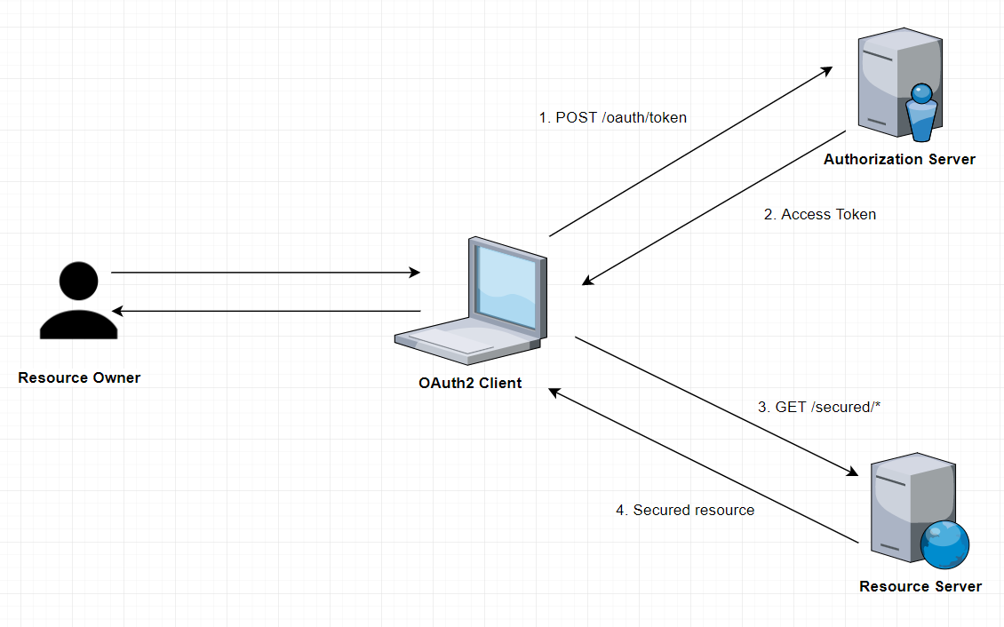
Advantages of using OAuth2 with JWT
- It is more popular in case microservices architecture where the single authentication server can be used for multiple resources server.
- Since the format of the token is JSON so it can be easily understood and managed on the client-side.

